**Collinearity Diagnostics, Model Fit & Variable Contribution**

**Collinearity Diagnostics**

Collinearity implies two variables are near perfect linear combinations of one another. Multicollinearity involves more than two variables. In the presence of multicollinearity, regression estimates are unstable and have high standard errors.

**VIF**

Variance inflation factors measure the inflation in the variances of the parameter estimates due to collinearities that exist among the predictors. It is a measure of how much the variance of the estimated regression coefficient βkβk is “inflated” by the existence of correlation among the predictor variables in the model. A VIF of 1 means that there is no correlation among the kth predictor and the remaining predictor variables, and hence the variance of βkβk is not inflated at all. The general rule of thumb is that VIFs exceeding 4 warrant further investigation, while VIFs exceeding 10 are signs of serious multicollinearity requiring correction.

Steps to calculate VIF:

* Regress the kthkth predictor on rest of the predictors in the model.
* Compute the R2kRk2

VIF=11−R2k=1ToleranceVIF=11−Rk2=1Tolerance

model <- **lm**(mpg ~ disp + hp + wt + qsec, data = mtcars)

**ols_vif_tol**(model)

## Variables Tolerance VIF

## 1 disp 0.1252279 7.985439

## 2 hp 0.1935450 5.166758

## 3 wt 0.1445726 6.916942

## 4 qsec 0.3191708 3.133119

**Tolerance**

Percent of variance in the predictor that cannot be accounted for by other predictors.

Steps to calculate tolerance:

* Regress the kthkth predictor on rest of the predictors in the model.
* Compute the R2kRk2

Tolerance=1−R2kTolerance=1−Rk2

**Condition Index**

Most multivariate statistical approaches involve decomposing a correlation matrix into linear combinations of variables. The linear combinations are chosen so that the first combination has the largest possible variance (subject to some restrictions we won’t discuss), the second combination has the next largest variance, subject to being uncorrelated with the first, the third has the largest possible variance, subject to being uncorrelated with the first and second, and so forth. The variance of each of these linear combinations is called an eigenvalue. Collinearity is spotted by finding 2 or more variables that have large proportions of variance (.50 or more) that correspond to large condition indices. A rule of thumb is to label as large those condition indices in the range of 30 or larger.

model <- **lm**(mpg ~ disp + hp + wt + qsec, data = mtcars)

**ols_eigen_cindex**(model)

## Eigenvalue Condition Index intercept disp hp

## 1 4.721487187 1.000000 0.000123237 0.001132468 0.001413094

## 2 0.216562203 4.669260 0.002617424 0.036811051 0.027751289

## 3 0.050416837 9.677242 0.001656551 0.120881424 0.392366164

## 4 0.010104757 21.616057 0.025805998 0.777260487 0.059594623

## 5 0.001429017 57.480524 0.969796790 0.063914571 0.518874831

## wt qsec

## 1 0.0005253393 0.0001277169

## 2 0.0002096014 0.0046789491

## 3 0.0377028008 0.0001952599

## 4 0.7017528428 0.0024577686

## 5 0.2598094157 0.9925403056

**Collinearity Diagnostics**

model <- **lm**(mpg ~ disp + hp + wt + qsec, data = mtcars)

**ols_coll_diag**(model)

## Tolerance and Variance Inflation Factor

## ---------------------------------------

## Variables Tolerance VIF

## 1 disp 0.1252279 7.985439

## 2 hp 0.1935450 5.166758

## 3 wt 0.1445726 6.916942

## 4 qsec 0.3191708 3.133119

##

##

## Eigenvalue and Condition Index

## ------------------------------

## Eigenvalue Condition Index intercept disp hp

## 1 4.721487187 1.000000 0.000123237 0.001132468 0.001413094

## 2 0.216562203 4.669260 0.002617424 0.036811051 0.027751289

## 3 0.050416837 9.677242 0.001656551 0.120881424 0.392366164

## 4 0.010104757 21.616057 0.025805998 0.777260487 0.059594623

## 5 0.001429017 57.480524 0.969796790 0.063914571 0.518874831

## wt qsec

## 1 0.0005253393 0.0001277169

## 2 0.0002096014 0.0046789491

## 3 0.0377028008 0.0001952599

## 4 0.7017528428 0.0024577686

## 5 0.2598094157 0.9925403056

**Model Fit Assessment**

**Residual Fit Spread Plot**

Plot to detect non-linearity, influential observations and outliers. Consists of side-by-side quantile plots of the centered fit and the residuals. It shows how much variation in the data is explained by the fit and how much remains in the residuals. For inappropriate models, the spread of the residuals in such a plot is often greater than the spread of the centered fit.

model <- **lm**(mpg ~ disp + hp + wt + qsec, data = mtcars)

**ols_plot_resid_fit_spread**(model)

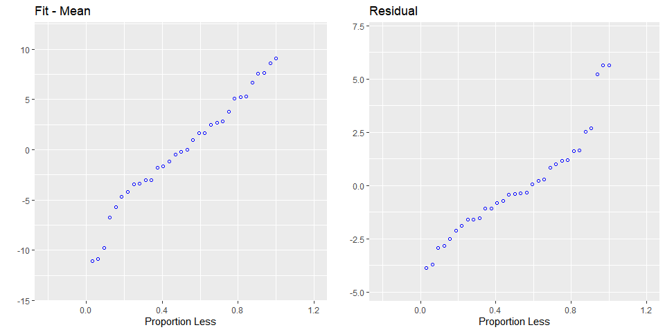**Part & Partial Correlations**

**Correlations**

Relative importance of independent variables in determining **Y**. How much each variable uniquely contributes to R2R2 over and above that which can be accounted for by the other predictors.

**Zero Order**

Pearson correlation coefficient between the dependent variable and the independent variables.

**Part**

Unique contribution of independent variables. How much R2R2 will decrease if that variable is removed from the model?

**Partial**

How much of the variance in **Y**, which is not estimated by the other independent variables in the model, is estimated by the specific variable?

model <- **lm**(mpg ~ disp + hp + wt + qsec, data = mtcars)

**ols_correlations**(model)

## Correlations

## -------------------------------------------

## Variable Zero Order Partial Part

## -------------------------------------------

## disp -0.848 0.048 0.019

## hp -0.776 -0.224 -0.093

## wt -0.868 -0.574 -0.285

## qsec 0.419 0.219 0.091

## -------------------------------------------

**Observed vs Predicted Plot**

Plot of observed vs fitted values to assess the fit of the model. Ideally, all your points should be close to a regressed diagonal line. Draw such a diagonal line within your graph and check out where the points lie. If your model had a high R Square, all the points would be close to this diagonal line. The lower the R Square, the weaker the Goodness of fit of your model, the more foggy or dispersed your points are from this diagonal line.

model <- **lm**(mpg ~ disp + hp + wt + qsec, data = mtcars)

**ols_plot_obs_fit**(model)

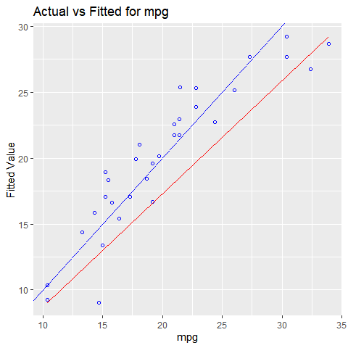**Lack of Fit F Test**

Assess how much of the error in prediction is due to lack of model fit. The residual sum of squares resulting from a regression can be decomposed into 2 components:

* Due to lack of fit
* Due to random variation

If most of the error is due to lack of fit and not just random error, the model should be discarded and a new model must be built. The lack of fit F test works only with simple linear regression. Moreover, it is important that the data contains repeat observations i.e. replicates for at least one of the values of the predictor x. This test generally only applies to datasets with plenty of replicates.

model <- **lm**(mpg ~ disp, data = mtcars)

**ols_pure_error_anova**(model)

## Lack of Fit F Test

## -----------------

## Response : mpg

## Predictor: disp

##

## Analysis of Variance Table

## ----------------------------------------------------------------------

## DF Sum Sq Mean Sq F Value Pr(>F)

## ----------------------------------------------------------------------

## disp 1 808.8885 808.8885 314.0095 1.934413e-17

## Residual 30 317.1587 10.57196

## Lack of fit 25 304.2787 12.17115 4.724824 0.04563623

## Pure Error 5 12.88 2.576

## ---------------------------------------------------------------------